Task 1 – Portfolio Website Design
You are building a personal portfolio website to showcase your work.
Requirements:
• Create sections for About Me, Projects, and Contact.
• Use AI to:
o Suggest color palettes and typography.
o Create a responsive layout with Grid/Flexbox.
o Add smooth scrolling navigation
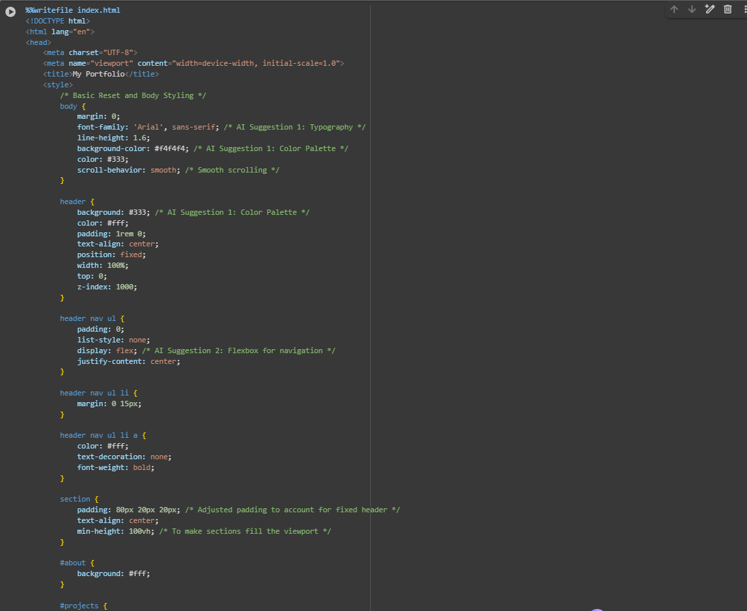

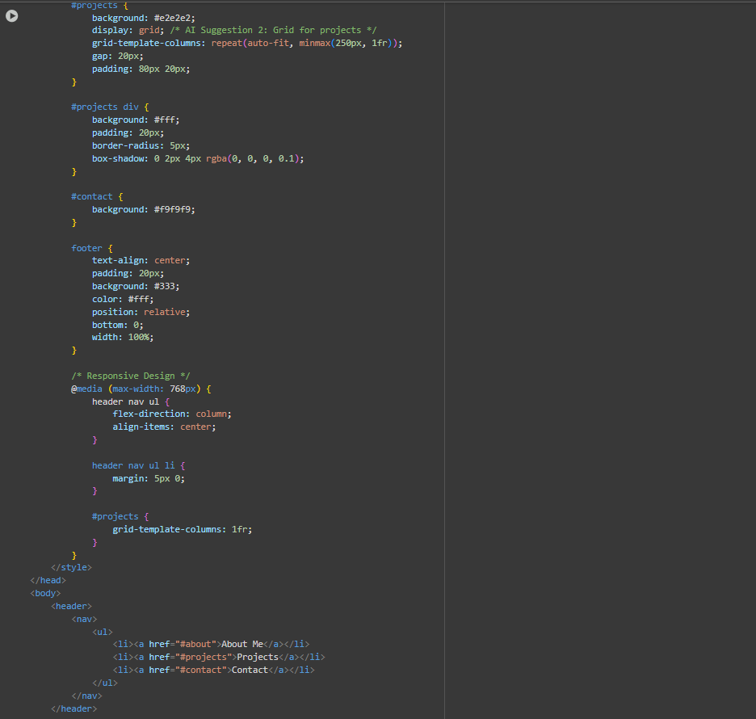

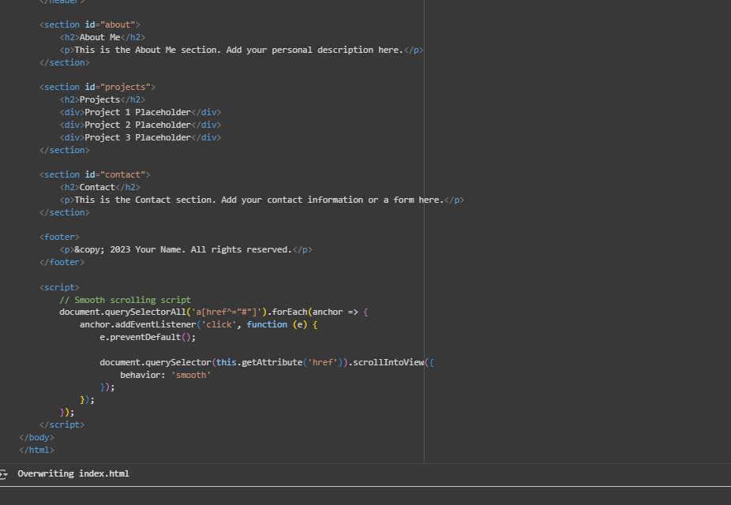

Observation : I have observed that I gives me html code that creates my portfolio

Task 2 – Online Store Product Page
Design a product display page for an online store.
Requirements:
• Display product image, title, price, and "Add to Cart" button.
• Use AI to:
o Style with BEM methodology.
o Make layout responsive.
o Add hover effects and "Add to Cart" alert.
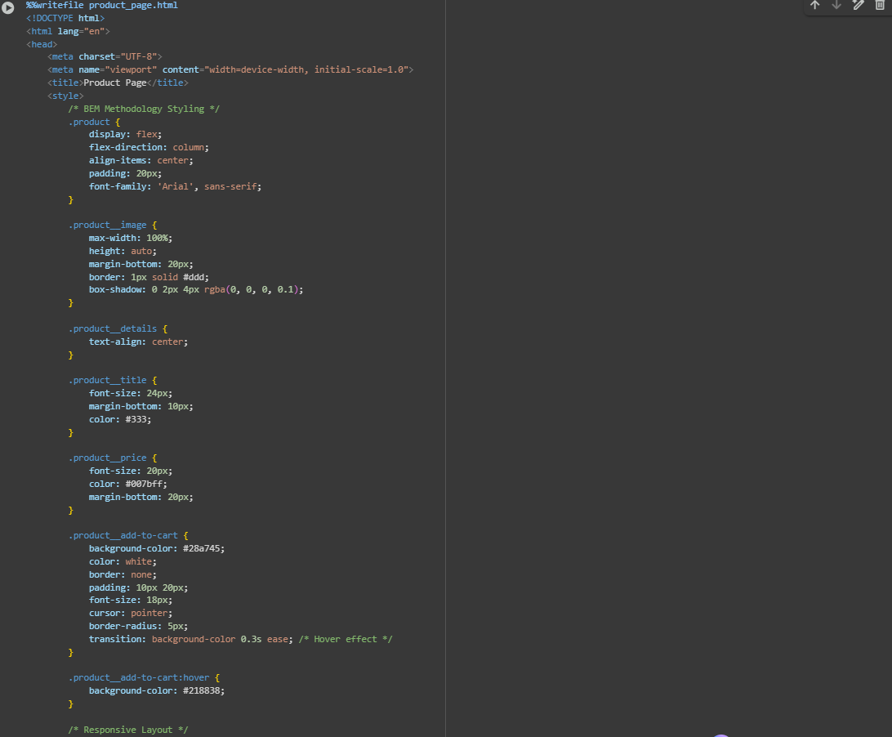
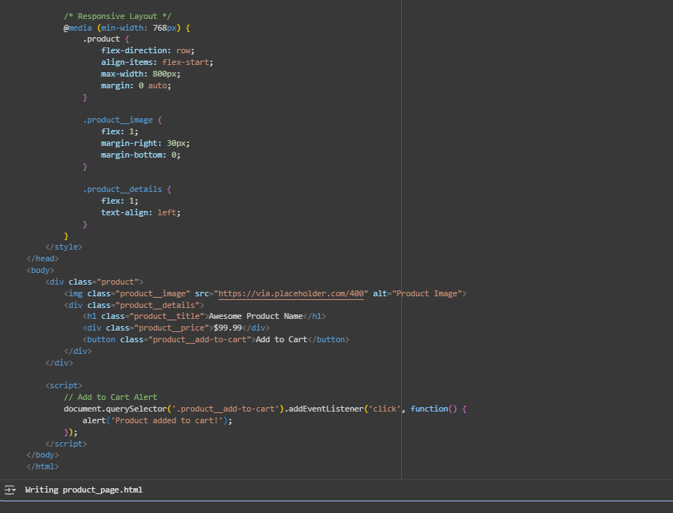
Observation : I have observed that it creates html code of online store product page by bem methodology

Task 3 – Event Registration Form
Build an event registration form for a conference.
Requirements:
• Collect name, email, phone number, and session selection.
• Use AI to:
o Add form validation with JavaScript.
o Make the form accessible with labels and ARIA.
o Style with a professional look.
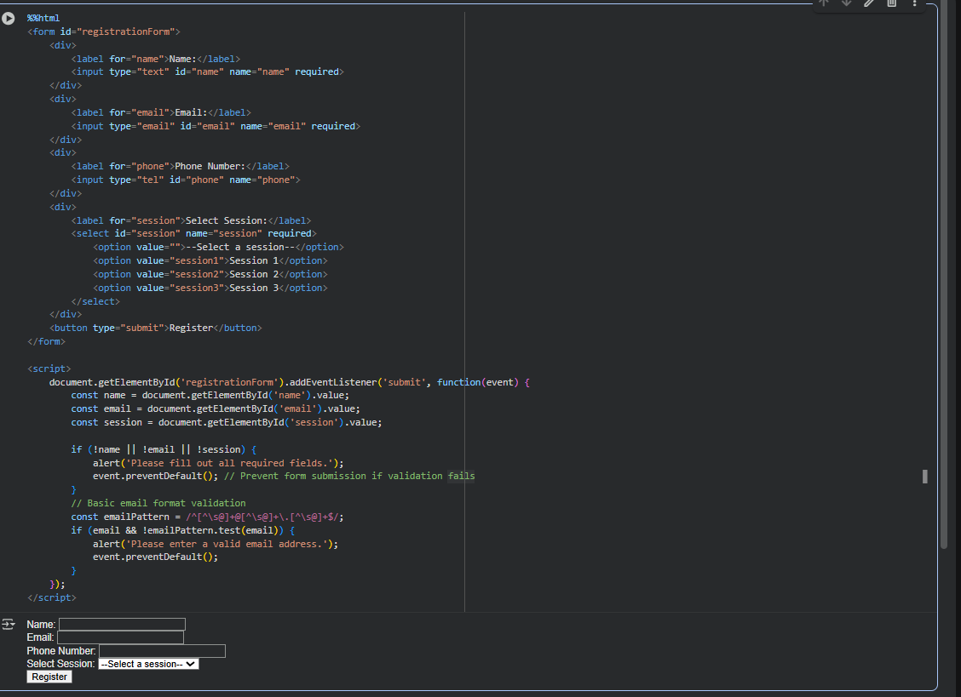
Observation :
I have Observed that it creates a html code for registration form

ask Description #4 (Data – Fetch API & Render List with
Loading/Error States)
• Task: Fetch JSON from an API and render items to the DOM
with loading and error UI.
• Instructions:
o Ask AI to write fetch() logic, create DOM nodes safely,
and add skeleton/loading text.

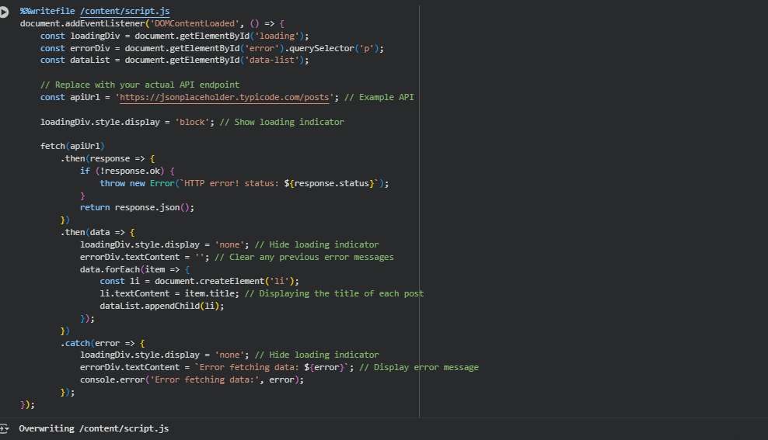
Observation : I have observed that The JavaScript file contains the logic to fetch data from a placeholder API and display it on the HTML page with loading and error handling.

